COMPUTER SECURITY

The National Institute of Standards and Technology (NIST) defines the term Computer Security as:

**“The protection afforded to an automated information system in order to attain the applicable objectives of preserving the integrity, availability, and confidentiality of information system resources (includes hardware, software, firmware, information/data, and telecommunications).”**

This definition introduces three key objectives of computer security:

* **Confidentiality**: This article covers two related concepts:
  + Data confidentiality
  + Privacy
* **Integrity**: This article covers two related concepts:
  + Data integrity
  + System integrity
* **Availability**: Assures that systems work promptly and service is not denied to authorized users.

CIA triad:

* **Confidentiality**: Preserving authorized restrictions on information access and disclosure, including means for protecting personal privacy and proprietary information.   
  A loss of confidentiality is the unauthorized disclosure of information.
* **Integrity**: Guarding against improper information modification or destruction, including ensuring information nonrepudiation and authenticity.   
  A loss of integrity is the unauthorized modification or destruction of information.
* **Availability**: Ensuring timely and reliable access to and use of information.  
  A loss of availability is the disruption of access to or use of information or an information system.

Although the use of the CIA triad to define security objectives is well established, some in the security field feel that additional concepts are needed to present a complete picture.

Therefore, two more concepts were included in it:

* Authenticity
* Accountability

The picture depicts requirements of computer security.

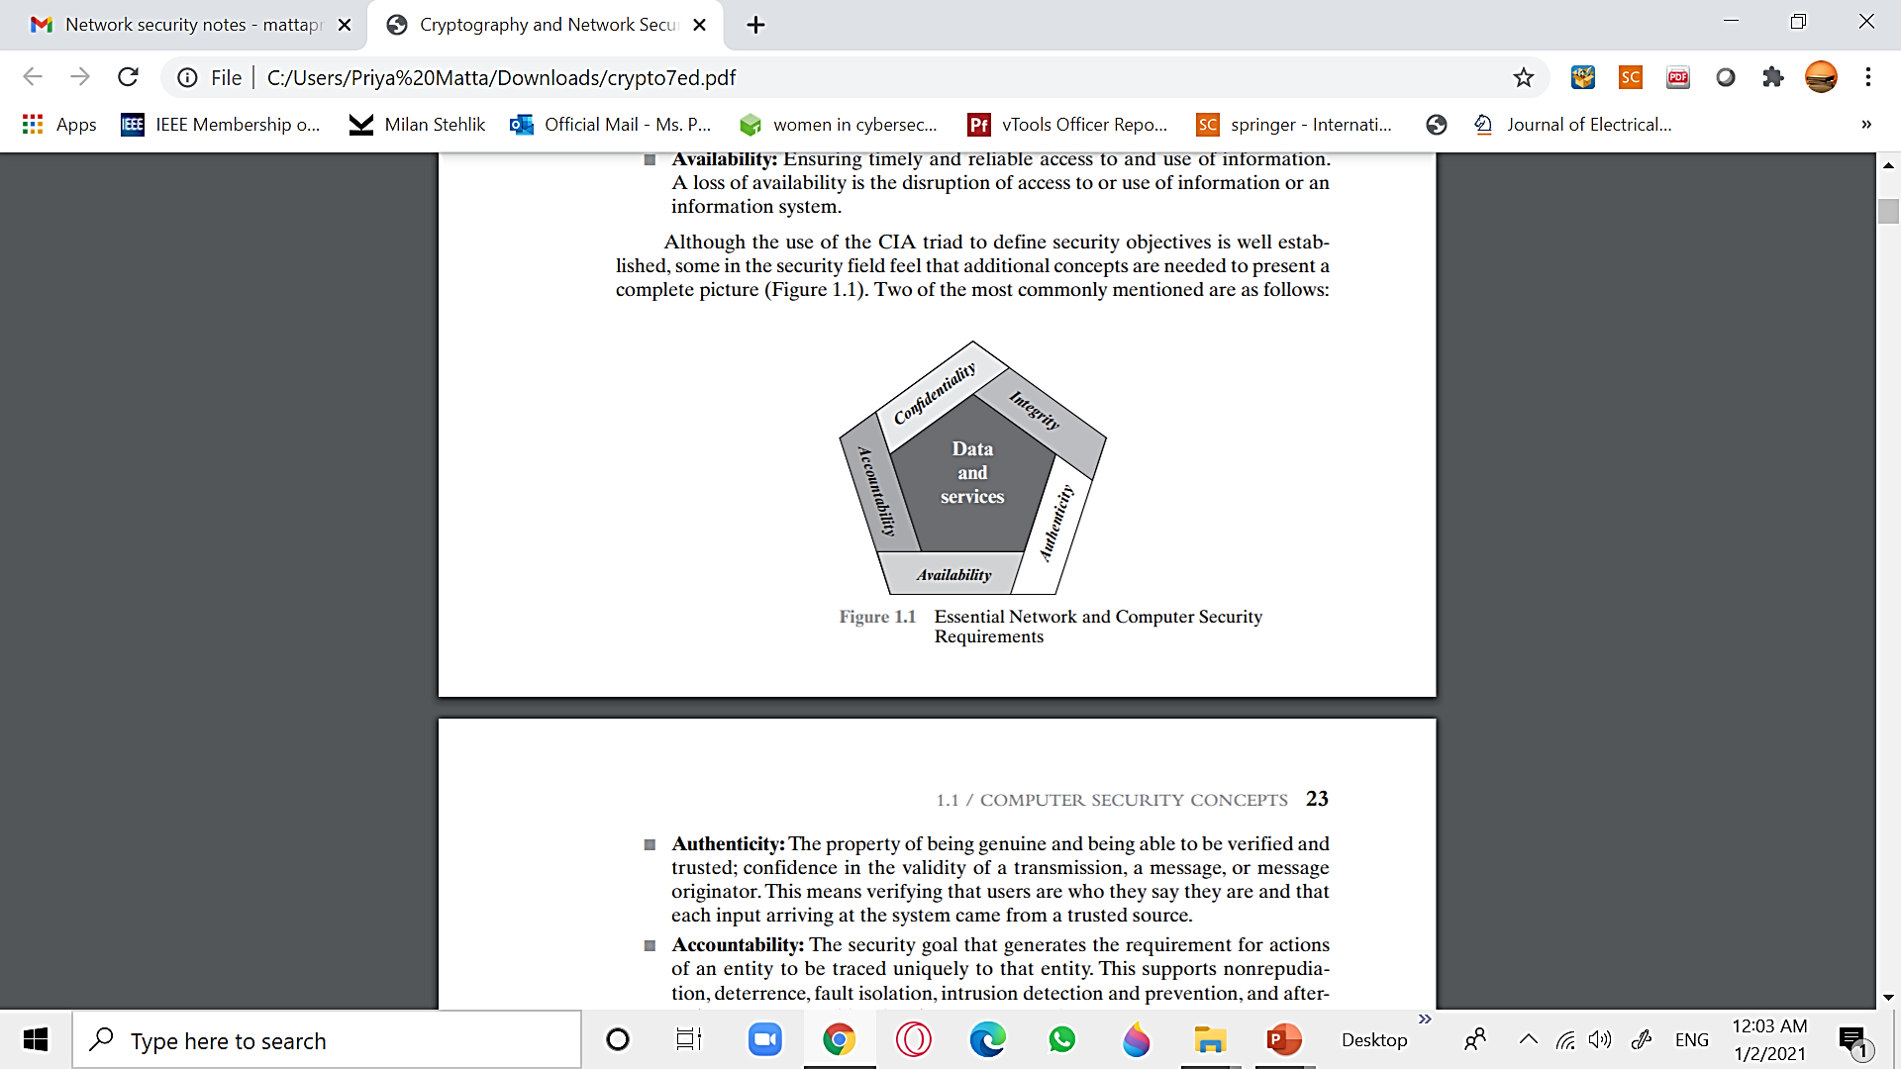

AUTHENTICITY:

The property of being genuine and being able to be verified and trusted; confidence in the validity of a transmission, a message, or message originator.   
This means verifying that users are who they say they are and that each input arriving at the system came from a trusted source.

ACCOUNTABILITY:

The security goal that generates the requirement for actions of an entity to be traced uniquely to that entity. This supports nonrepudiation, deterrence, fault isolation, intrusion detection and prevention, and after-action recovery and legal action.

* Since truly secure systems are not yet an achievable goal, we must be able to trace a security breach to a responsible party.
* Systems must keep records of their activities to permit later forensic analysis to trace security breaches or to aid in transaction disputes.

The Challenges of Computer Security:

1. **Security** is not as simple as it might first appear to the novice. Security services can be given self-explanatory, one-word labels: confidentiality, authentication, nonrepudiation, or integrity, but the mechanisms used to meet those requirements can be quite complex, and understanding them may involve rather subtle reasoning.

2. In developing a particular security mechanism or algorithm, one must always consider **potential attacks** on those security features. In many cases, successful attacks are designed by looking at the problem in a completely different way, therefore exploiting an unexpected weakness in the mechanism.

3. It is necessary to decide **where to use** the **security mechanisms**. This is true both in terms of physical placement (e.g., at what points in a network are certain security mechanisms needed) and in a logical sense (e.g., at what layer or layers of an architecture such as TCP/IP [Transmission Control Protocol/Internet Protocol] should mechanisms be placed).

4. Security mechanisms typically involve more than a particular **algorithm** or **protocol**. They also require that participants be in possession of some secret information (e.g., an encryption key), which raises questions about the creation, distribution, and protection of that secret information. There also may be a reliance on **communications protocols** whose behavior may complicate the task of developing the security mechanism.

5. Computer and network security is essentially a battle of wits between a perpetrator who tries to find holes and the designer or administrator who tries to close them. The great advantage that the attacker has is that he or she need only find a single **weakness** **of the system**, while the designer must find and eliminate all weaknesses to achieve perfect security.

7. There is a natural tendency on the part of users and system managers to perceive little benefit from security investment until a **security failure** occurs.

8. Security requires regular, even **constant** **monitoring**, and this is difficult in today’s short-term, overloaded environment.

9. Security is still too often an afterthought to be incorporated into a system after the design is complete rather than being an **integral part of the design process**.

10. Many users and even security administrators view strong security as an impediment to efficient and **user-friendly operation** of an information system or use of information.

Report By: Gaurangi Tripathi, B. Tech – CSE (2nd Year), 2020.